Software Design Document
<AI-Based Real-Time Voice Cloning and Emotion-Aware Communication System>



Submitted by:
Nimra Shahzad
S23BINFT1E02065
Submitted to:
Mr. Omer Riaz

Department of Information Technology
Faculty of Computing
The Islamia University of Bahawalpur
Meeting Details

Sr No. | Details | Date | Supervisor Signature

Summary
This Software Design Document (SDD) presents the design and architecture of the AI-Based Real-Time Voice Cloning and Emotion-Aware Communication System. The system combines real-time voice communication, speech emotion recognition, voice cloning, and analytics generation into a unified web-based platform.
The design follows a modular client-server architecture where the frontend manages user interaction, the backend handles communication and business logic, and dedicated AI modules perform emotion detection and voice synthesis tasks. The document explains the application architecture, database schema, user interface design, API interactions, and design considerations used during system development.

Table of Contents
- Application Architecture
1.1 Architectural Overview
1.2 System Components
1.3 MVC Architecture
1.4 Controllers and Functions
1.5 APIs and Libraries
1.6 UML Diagrams
1.7 Coding Conventions
- Data Model Schema
2.1 Database Overview
2.2 User Entity
2.3 Session Entity
2.4 Emotion Log Entity
2.5 ER Diagram Description
- User Interface
3.1 Design Philosophy
3.2 Color Scheme
3.3 Responsive Design
3.4 Screen Descriptions
4. References

1. Application Architecture

1.1 Architectural Overview
The system follows a Client-Server Architecture consisting of:

Frontend Layer
- React.js Web Application
- User Authentication Interface
- Voice Communication Interface
- Analytics Dashboard

Backend Layer
- FastAPI Server
- Authentication Services
- Session Management
- AI Model Integration

AI Processing Layer
- Speech Emotion Recognition Model
- Voice Cloning Model
- Audio Feature Extraction Module

Database Layer
- MongoDB Database
- User Data Storage
- Session Logs
- Emotion Analytics Storage

1.2 System Components

Frontend Module
Responsibilities:
- User registration
- User login
- Voice session controls
- Emotion display
- Analytics visualization

Backend Module
Responsibilities:
- User authentication
- API management
- Audio processing requests
- Communication handling
- Database operations

Emotion Detection Module
Responsibilities:
- Receive audio chunks
- Extract MFCC features
- Classify emotions
- Return emotion labels
Supported Emotions:
- Happy
- Sad
- Angry
- Neutral

Voice Cloning Module
Responsibilities:
- Accept voice samples
- Generate voice embeddings
- Convert text to synthesized speech
- Produce cloned voice output

Analytics Module
Responsibilities:
- Store emotion predictions
- Generate session reports
- Create trend graphs
- Calculate emotional statistics

1.3 MVC Architecture

Models
- User Model
- Session Model
- EmotionLog Model

Views
- Login Page
- Registration Page
- Dashboard Page
- Voice Session Page
- Analytics Page

Controllers
- Authentication Controller
- Session Controller
- Emotion Controller
- Voice Cloning Controller
- Analytics Controller

1.4 Controllers and Functions

Authentication Controller
Functions:
registerUser()
loginUser()
logoutUser()
validateCredentials()

Session Controller
Functions:
createSession()
startSession()
endSession()
storeSessionData()

Emotion Controller
Functions:
processAudio()
extractFeatures()
predictEmotion()
saveEmotionLog()

Voice Cloning Controller
Functions:
uploadVoiceSample()
trainVoiceProfile()
generateSpeech()
deleteVoiceProfile()

Analytics Controller
Functions:
generateReport()
getEmotionHistory()
calculateStatistics()
createGraphs()

1.5 APIs and Libraries

Internal APIs

Authentication API
POST /register
POST /login
POST /logout

Session API
POST /session/start
POST /session/end
GET /session/history

Emotion API
POST /emotion/predict
GET /emotion/history

Voice Cloning API
POST /voice/upload
POST /voice/generate
DELETE /voice/delete

External Libraries
Library | Purpose
Librosa | Audio feature extraction
TensorFlow/PyTorch | AI model execution
Coqui TTS / XTTS | Voice cloning
WebRTC | Real-time communication
FastAPI | Backend framework
React.js | Frontend framework
MongoDB | Database

1.6 UML Diagrams
Include the following diagrams:

Class Diagram
Classes:
User
Session
EmotionLog
EmotionDetector
VoiceCloner
AnalyticsManager
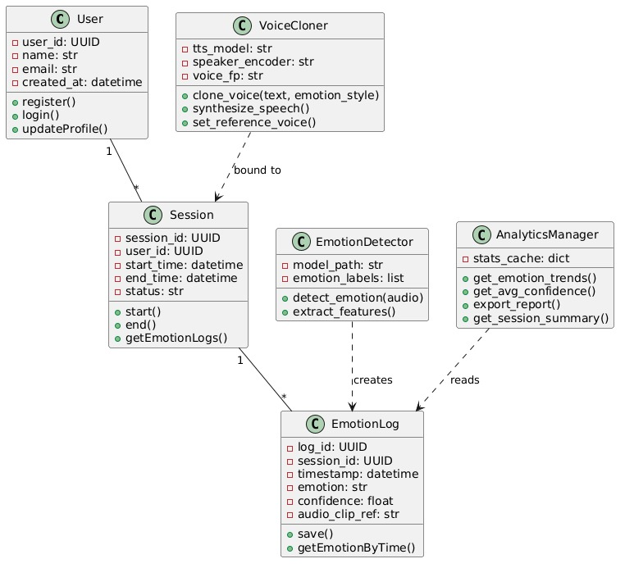

· Figure 1: Class Diagram of AI-Based Real-Time Voice Cloning and Emotion-Aware Communication System

Sequence Diagram
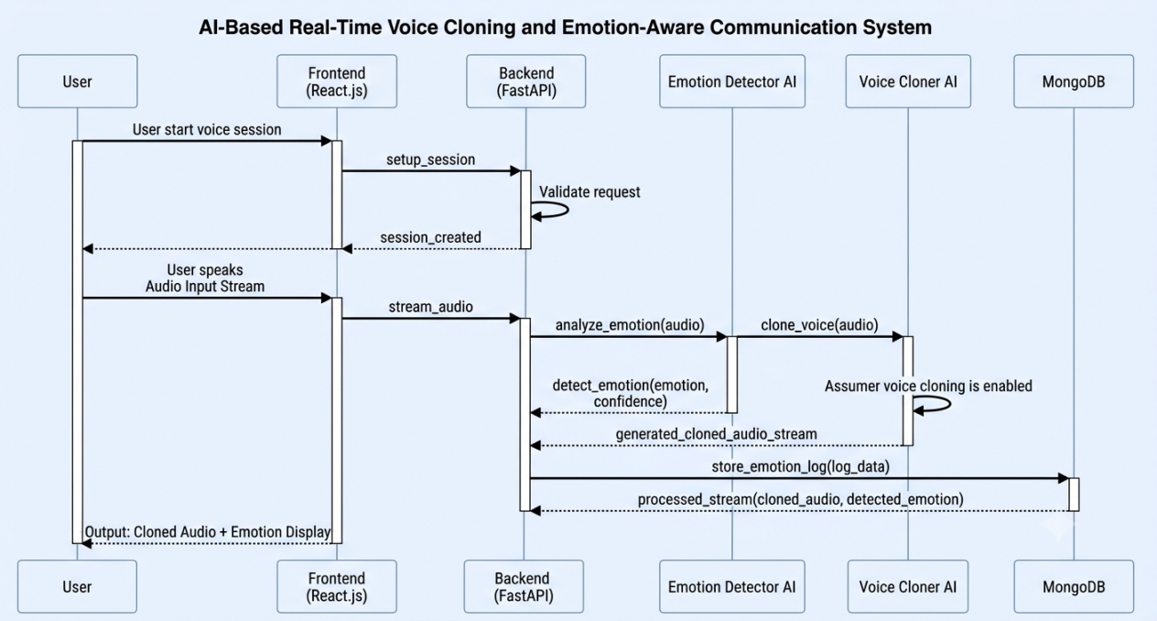
Figure 2: Sequence Diagram of Real-Time Voice Communication and Emotion Detection Flow
Flow:
User → Frontend
Frontend → Backend
Backend → Emotion Model
Emotion Model → Backend
Backend → Database
Backend → Frontend

Deployment Diagram
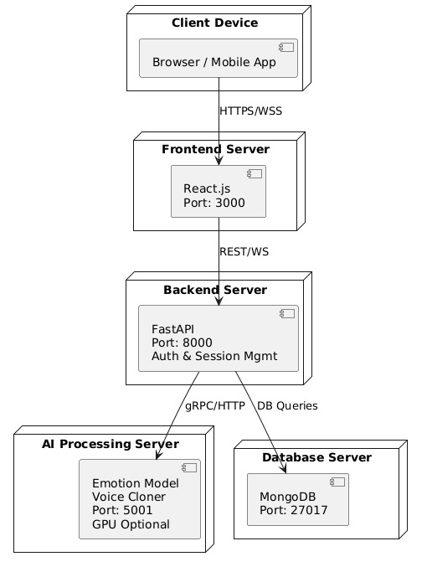
Figure 3: Deployment Diagram of AI-Based Voice Cloning System Architecture
Client Device
|
Application Server
|
AI Processing Server
|
Database Server

1.7 Coding Conventions

Naming Convention
Variables:
user_name
emotion_label
session_id
Functions:
predictEmotion()
generateSpeech()
storeSessionData()
Classes:
User
EmotionDetector
VoiceCloner

Formatting
- 4-space indentation
- Meaningful variable names
- Comments for complex logic
- Modular file structure

2. Data Model Schema

2.1 Database Overview
The system uses MongoDB for storing:
- User information
- Voice session records
- Emotion logs
- Analytics reports

2.2 User Entity

Attributes
Attribute | Type
UserID | ObjectID
Name | String
Email | String
Password | String
CreatedAt | Timestamp
VoiceCloningEnabled | Boolean
Purpose:
Stores registered user information and account settings.

2.3 Session Entity

Attributes
Attribute | Type
SessionID | ObjectID
UserID | ObjectID
StartTime | Timestamp
EndTime | Timestamp
Duration | Integer
CloningUsed | Boolean
Purpose:
Stores voice communication session details.

2.4 Emotion Log Entity

Attributes
Attribute | Type
LogID | ObjectID
SessionID | ObjectID
Timestamp | Timestamp
DetectedEmotion | String
ConfidenceScore | Float
Purpose:
Stores emotion predictions generated during live communication.

2.5 ER Diagram Description
Relationship Structure:
User
|
1:M
|
Session
|
1:M
|
EmotionLog

Explanation:
- One User can create multiple Sessions.
- One Session can contain multiple Emotion Logs.
- Emotion Logs depend on Session records.
- Session records depend on User records.
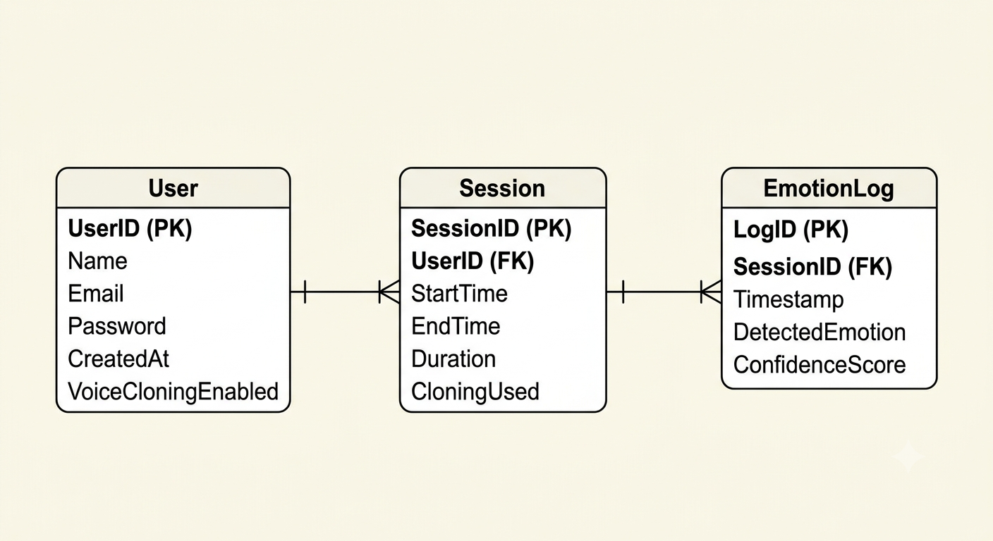
Figure 4: Entity-Relationship (ER) Diagram of System Database Schema

3. User Interface

3.1 Design Philosophy
The interface is designed to be:
- Simple
- Minimalistic
- User-friendly
- Responsive
- AI-focused
The goal is to allow users to start communication sessions with minimal complexity.

3.2 Color Scheme
Element | Color
Primary | #2563EB (Blue)
Secondary | #10B981 (Green)
Background | #F8FAFC
Text | #1F2937
Warning | #EF4444

3.3 Typography
Font Family:
Poppins
Roboto
Font Sizes:
Heading: 24px
Subheading: 18px
Body Text: 14px

3.4 Responsive Design
Supported Devices:
- Desktop
- Laptop
- Tablet
- Mobile
Responsive breakpoints:
Mobile: <768px
Tablet: 768px–1024px
Desktop: >1024px

Screen 1 – Login Page

Controls
- Email Textbox
- Password Textbox
- Login Button
- Register Link

Input Constraints
- Valid email format
- Minimum password length: 8 characters

Screen 2 – Registration Page

Controls
- Name Textbox
- Email Textbox
- Password Textbox
- Confirm Password Textbox
- Register Button

Input Constraints
- Required fields
- Unique email

Screen 3 – Voice Session Page

Controls
- Start Session Button
- End Session Button
- Microphone Indicator
- Emotion Display Panel

Displayed Data
- Current emotion
- Session duration
- Connection status

Screen 4 – Voice Cloning Page

Controls
- Upload Voice Sample
- Text Input Field
- Generate Voice Button
- Audio Playback Player

Constraints
- Supported formats: WAV, MP3
- Maximum file size: 20 MB

Screen 5 – Analytics Dashboard

Controls
- Session History Table
- Emotion Trend Graph
- Emotion Distribution Chart
- Export Report Button

Displayed Data
- Emotion percentages
- Session summaries
- Historical analytics

References
- FastAPI Documentation — https://fastapi.tiangolo.com/
- React.js Documentation — https://react.dev/
- MongoDB Manual — https://www.mongodb.com/docs/
- Librosa Audio Library — https://librosa.org/
- PyTorch Documentation — https://pytorch.org/
- TensorFlow Documentation — https://www.tensorflow.org/
- Coqui TTS (Voice Cloning) — https://coqui.ai/
- WebRTC Documentation — https://webrtc.org/

